CHALLENGE FOR VPC
Use Case: Setting up Transit Gateway and VPC Endpoints for a Multi-VPC Architecture
Scenario:
A large organization is migrating its on-premises infrastructure to the AWS cloud.
The organization's architecture involves multiple VPCs for different departments and applications, each requiring secure communication with centralized services and external resources.
The IT team needs to design and implement a scalable and efficient network architecture to accommodate the organization's growth and ensure robust connectivity between VPCs and external services.
Objectives:
- Design and deploy a scalable network architecture using AWS Transit Gateway to simplify network connectivity between multiple VPCs.
- Configure VPC endpoints to securely access AWS services without internet gateways or NAT gateways, ensuring data privacy and minimizing exposure to external threats.

- Set up a VPC Transit Gateway.
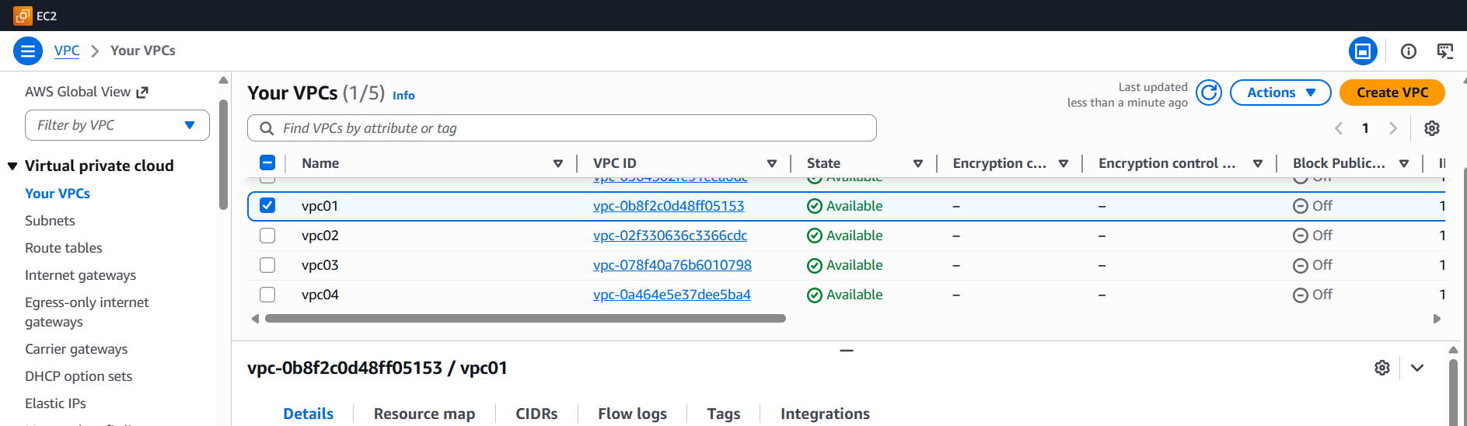
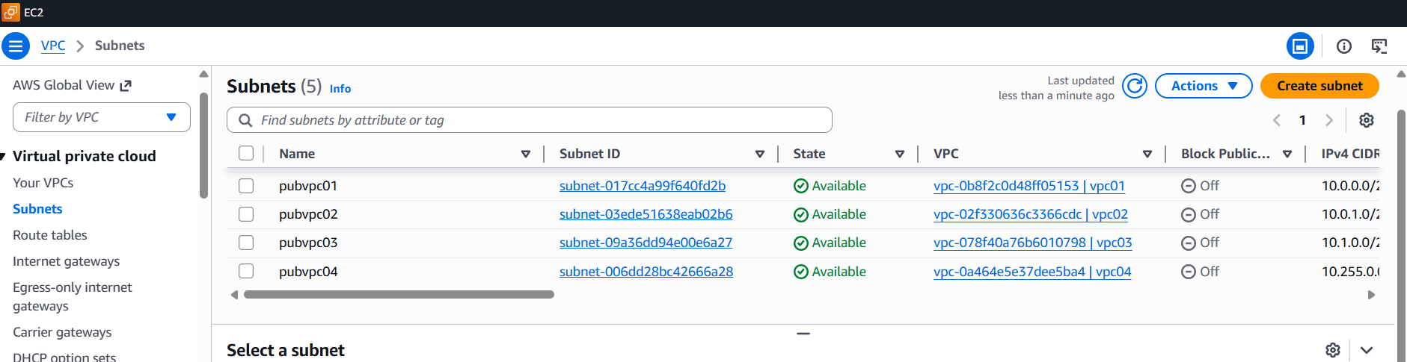
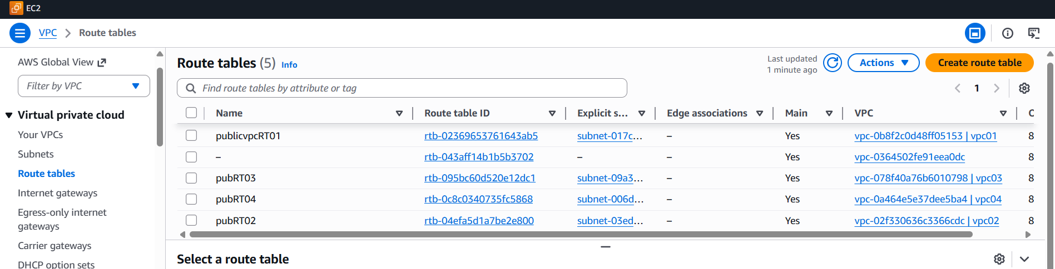
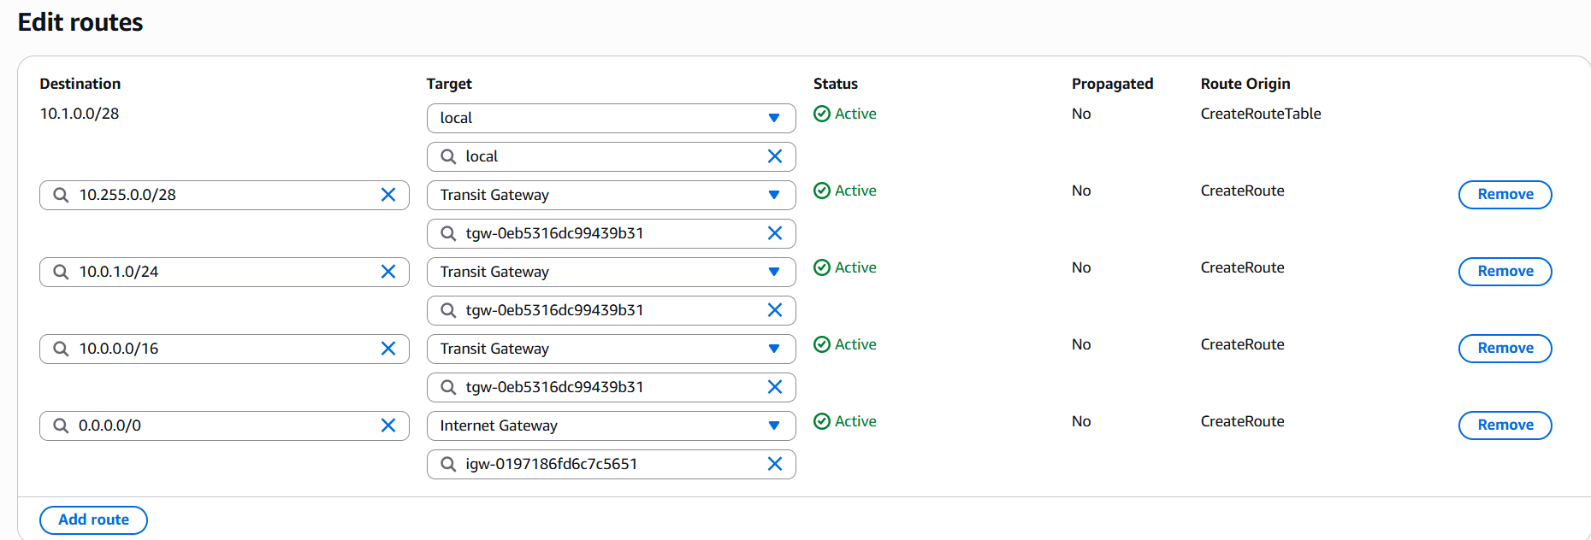
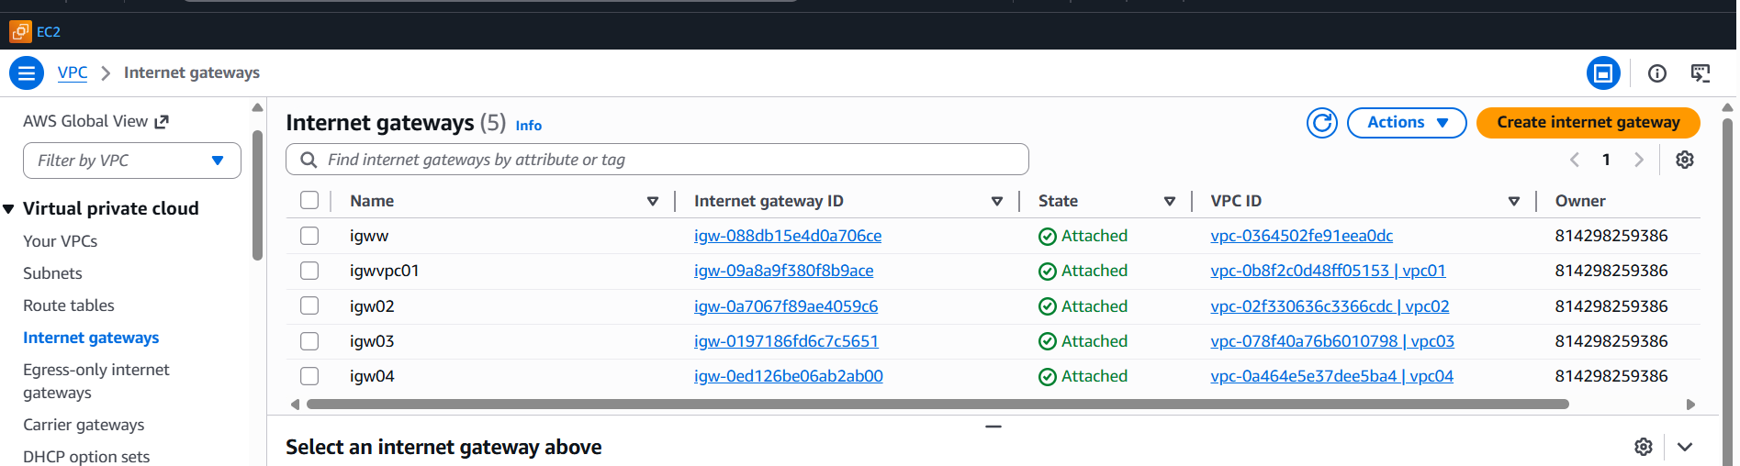
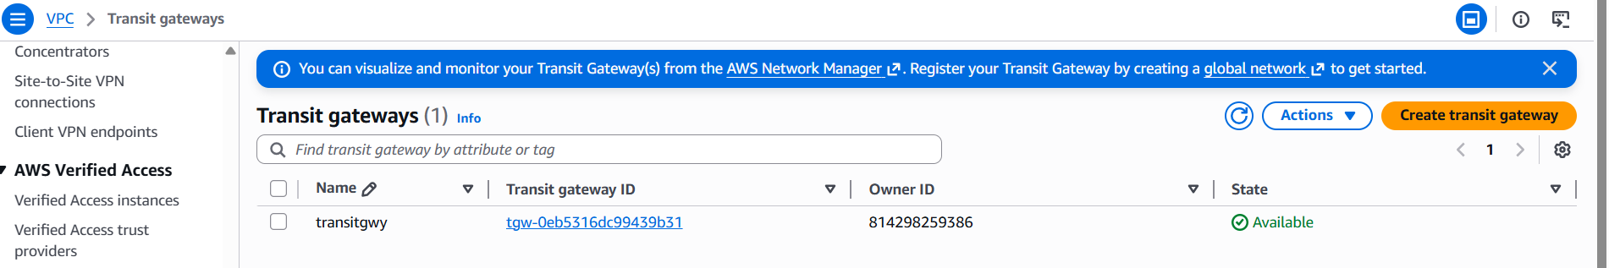
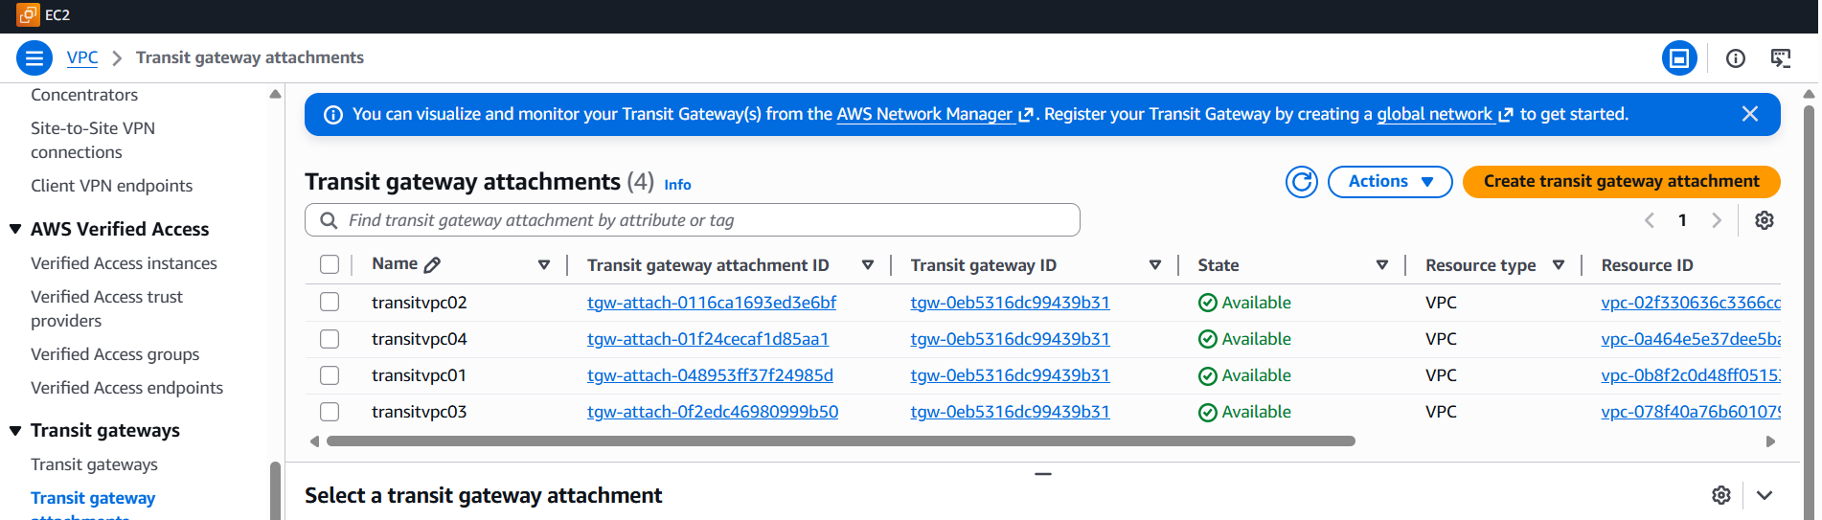
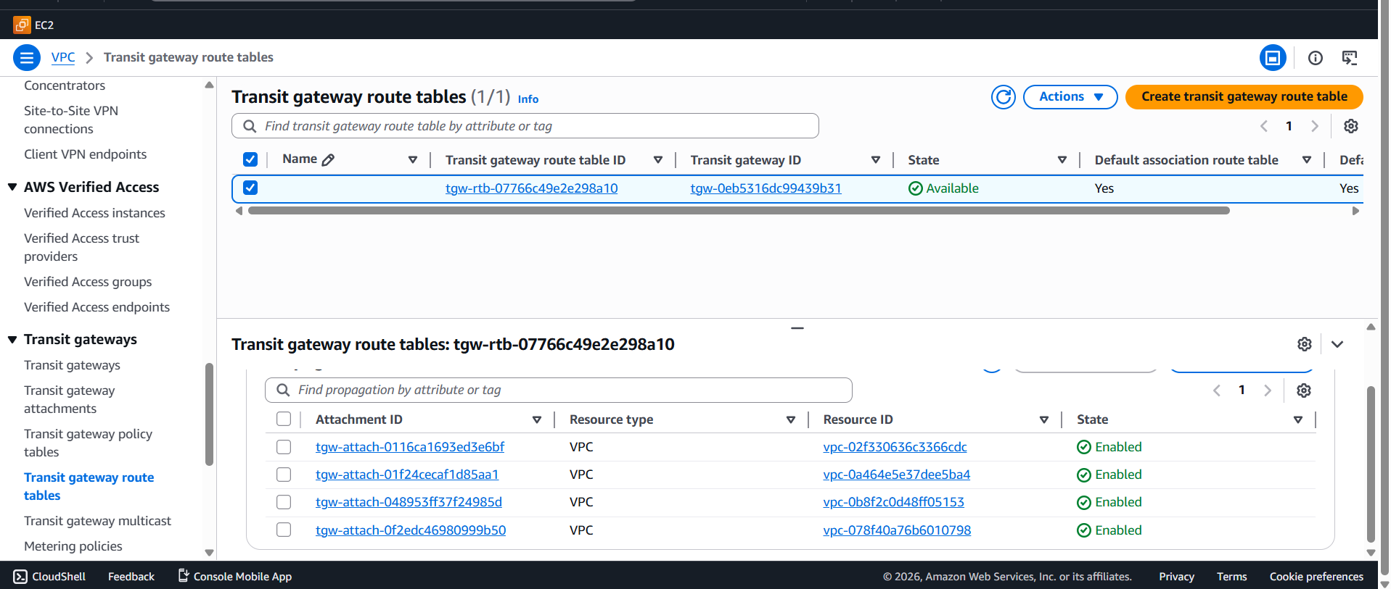
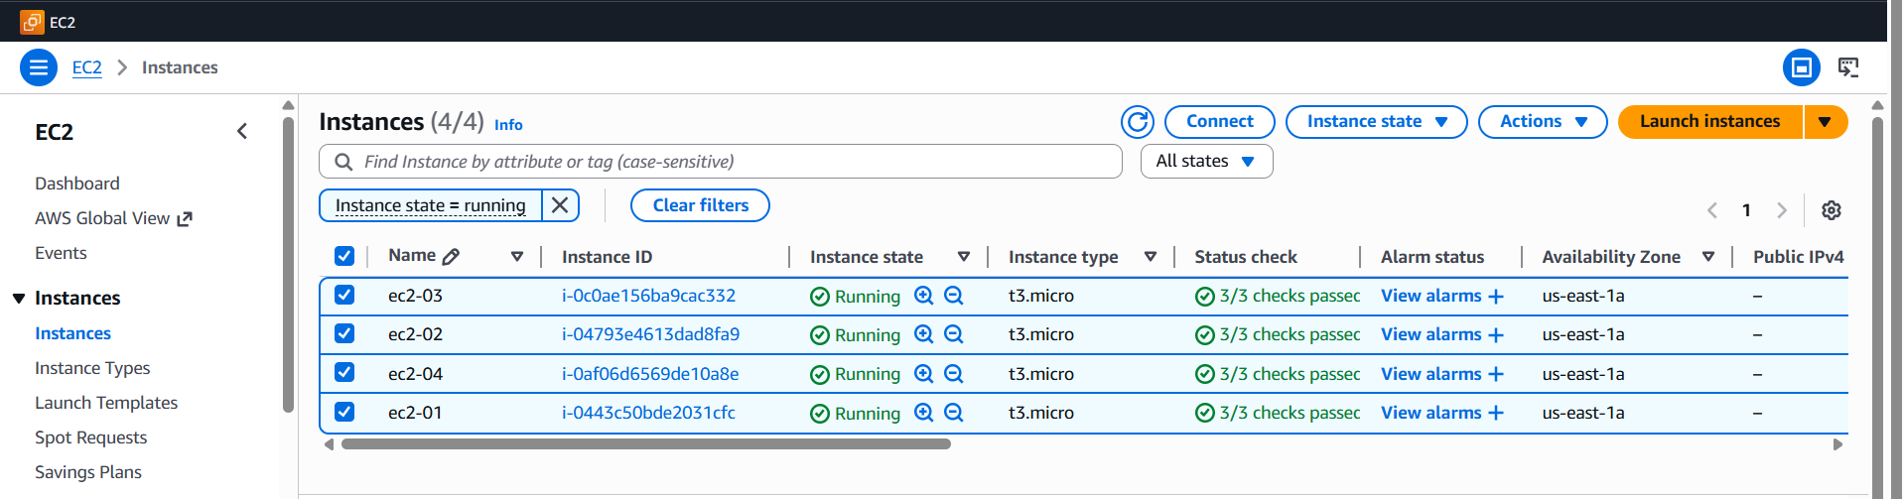
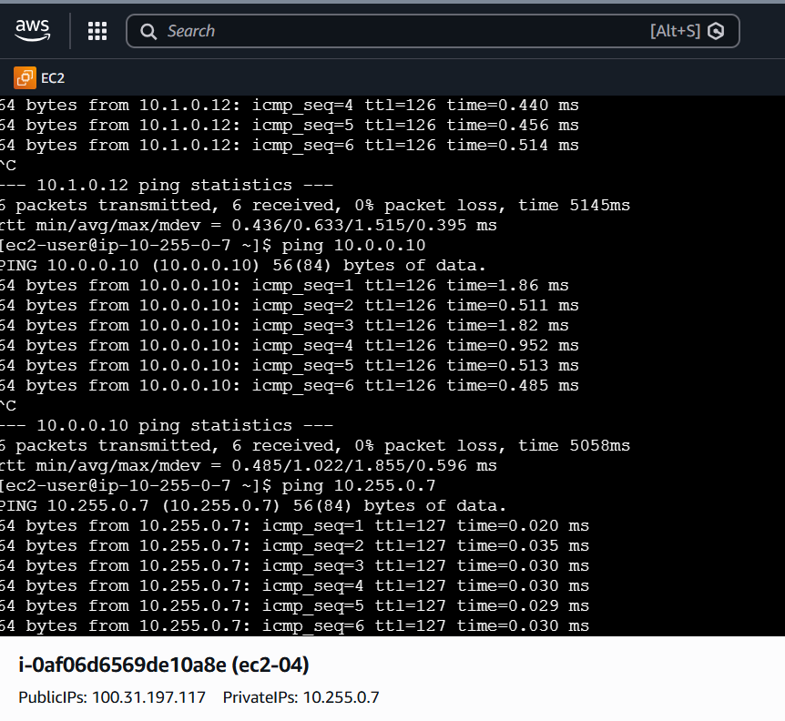
- Set up a VPC Endpoint.
